There is an undirected **star** graph consisting of n nodes labeled from 1 to n. A star graph is a graph where there is one **center** node and **exactly** n - 1 edges that connect the center node with every other node.

You are given a 2D integer array edges where each edges[i] = [ui, vi] indicates that there is an edge between the nodes ui and vi. Return the center of the given star graph.

**Example 1:**

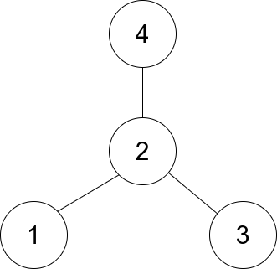

**Input:** edges = [[1,2],[2,3],[4,2]]

**Output:** 2

**Explanation:** As shown in the figure above, node 2 is connected to every other node, so 2 is the center.

**Example 2:**

**Input:** edges = [[1,2],[5,1],[1,3],[1,4]]

**Output:** 1

**Constraints:**

* 3 <= n <= 105
* edges.length == n - 1
* edges[i].length == 2
* 1 <= ui, vi <= n
* ui != vi
* The given edges represent a valid star graph.